Overview of the practical exam for 2365 1
Light switch Step one 2
Light Switch Step Two 2
Light switch Step three 3
Steel conduit - Ring Circuit 3
SWA Radial Circuit 3

Overview of the practical exam for 2365

The overall schematic for the circuit board that I my cohorts and I had to installation as part of the final assessment for the 2365 level 2 diploma.

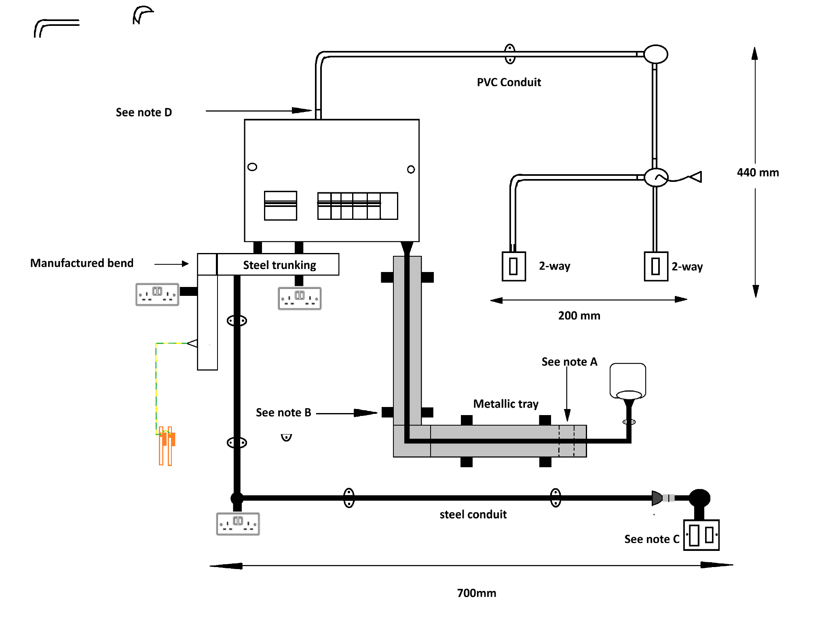

Light switch

The light circuit is on a 6 amp breaker.

Step One light
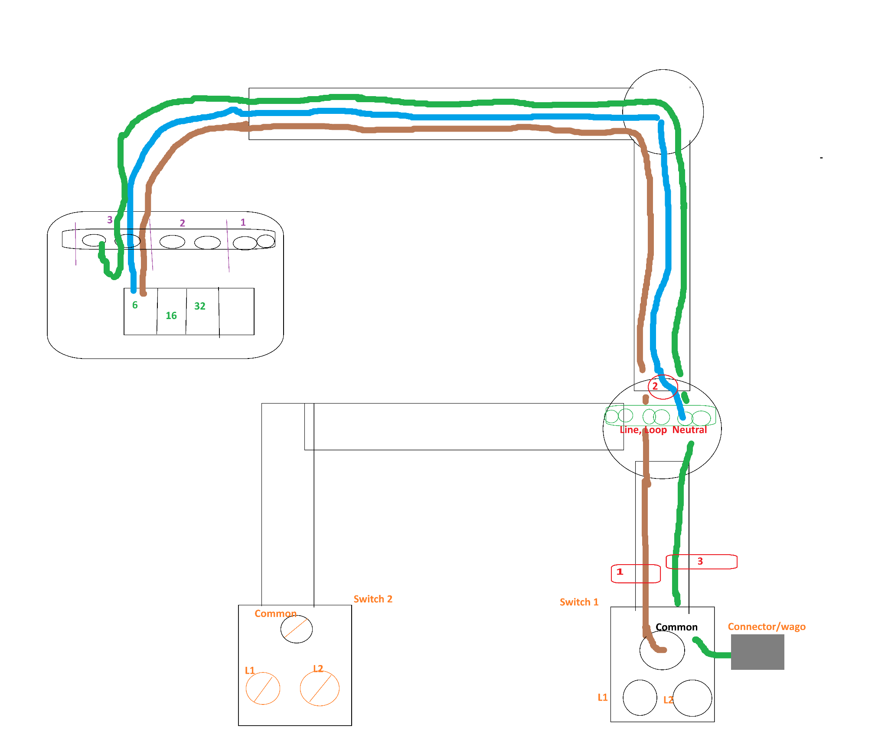

Step Two
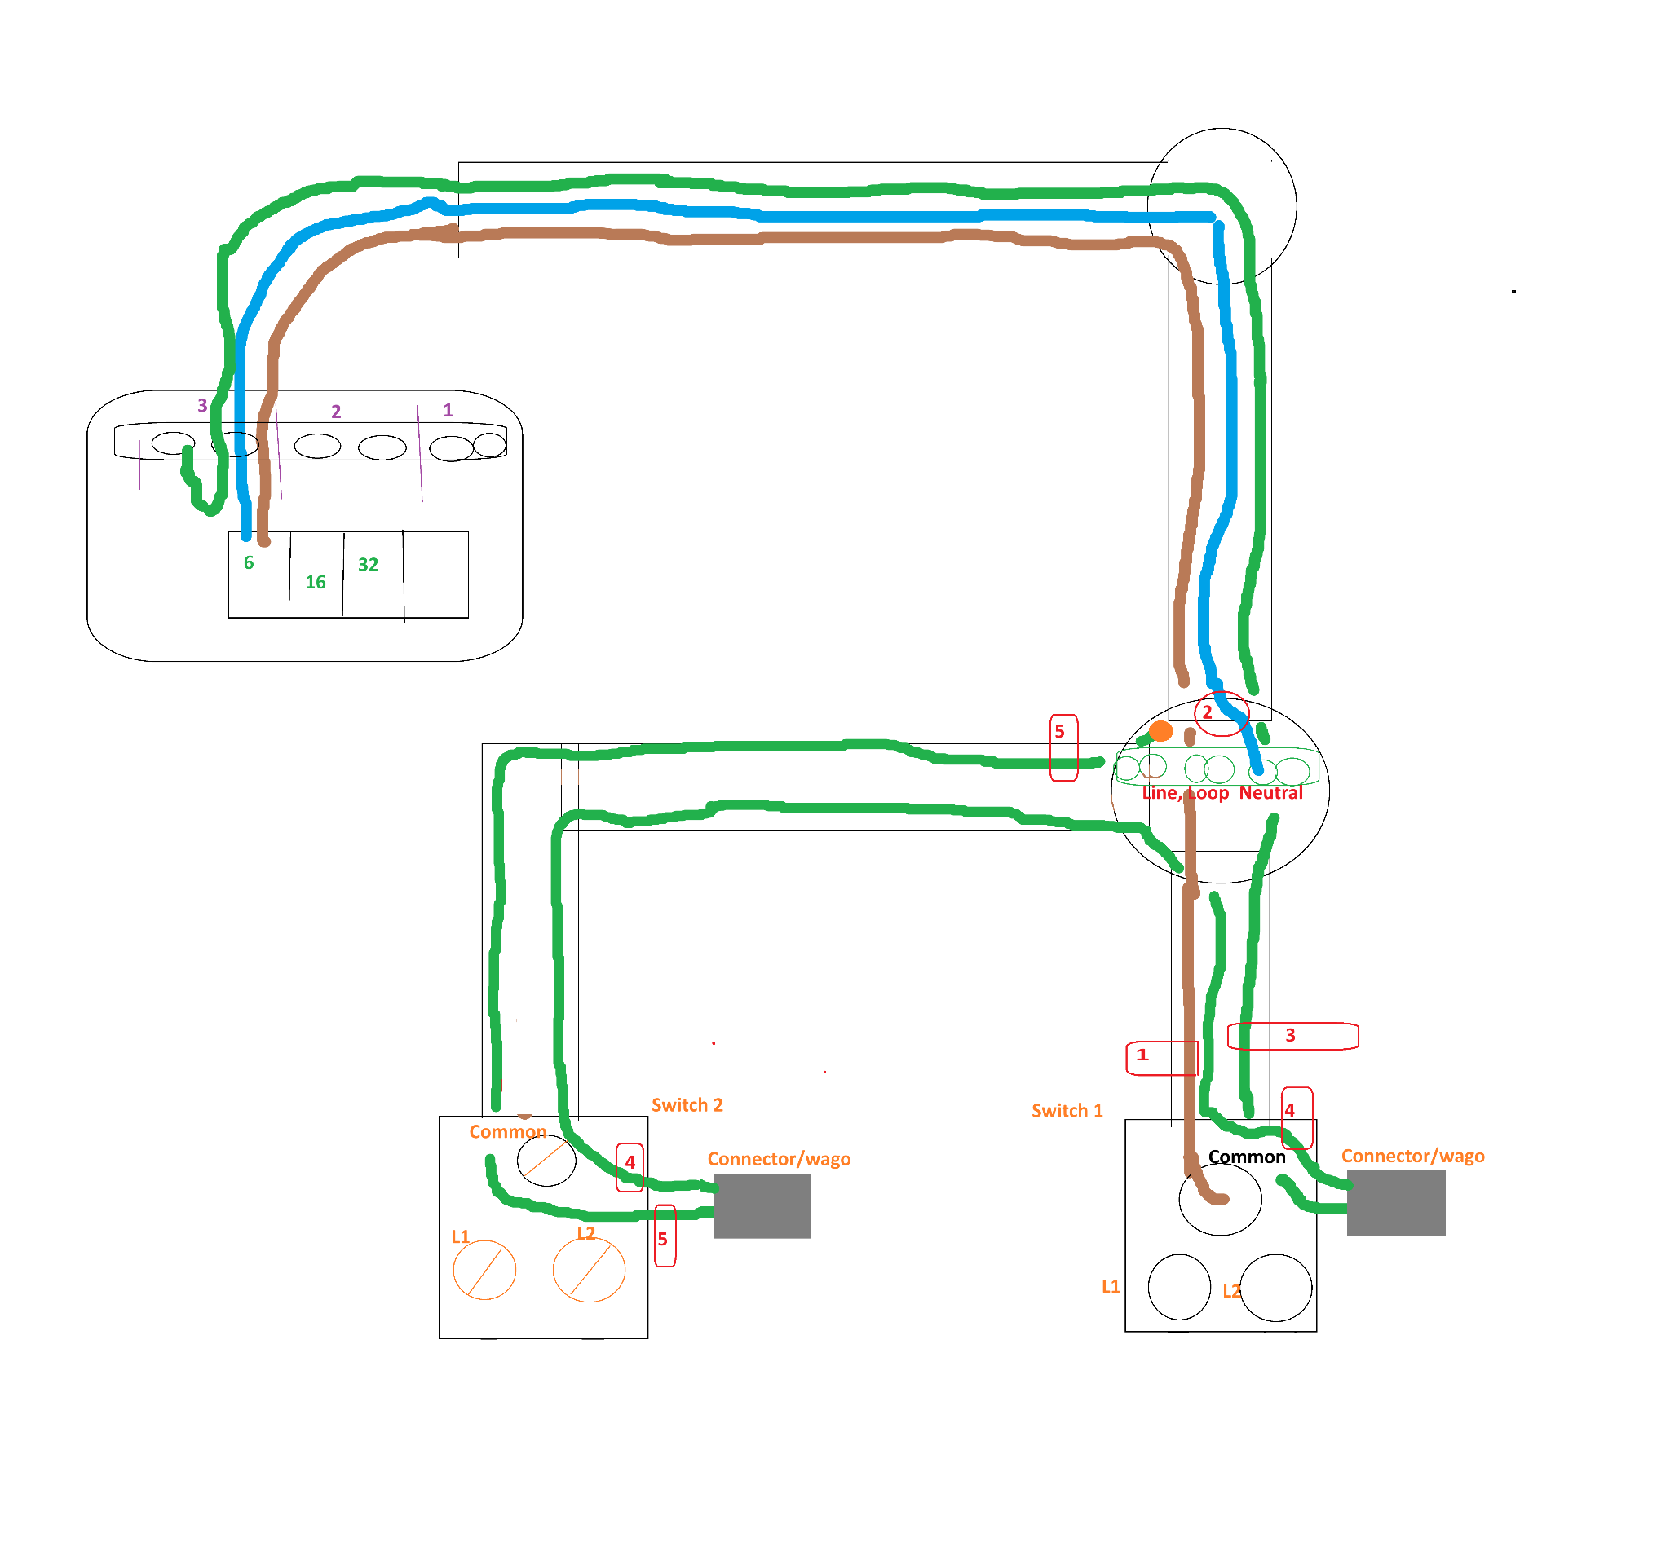

Step three - strappers
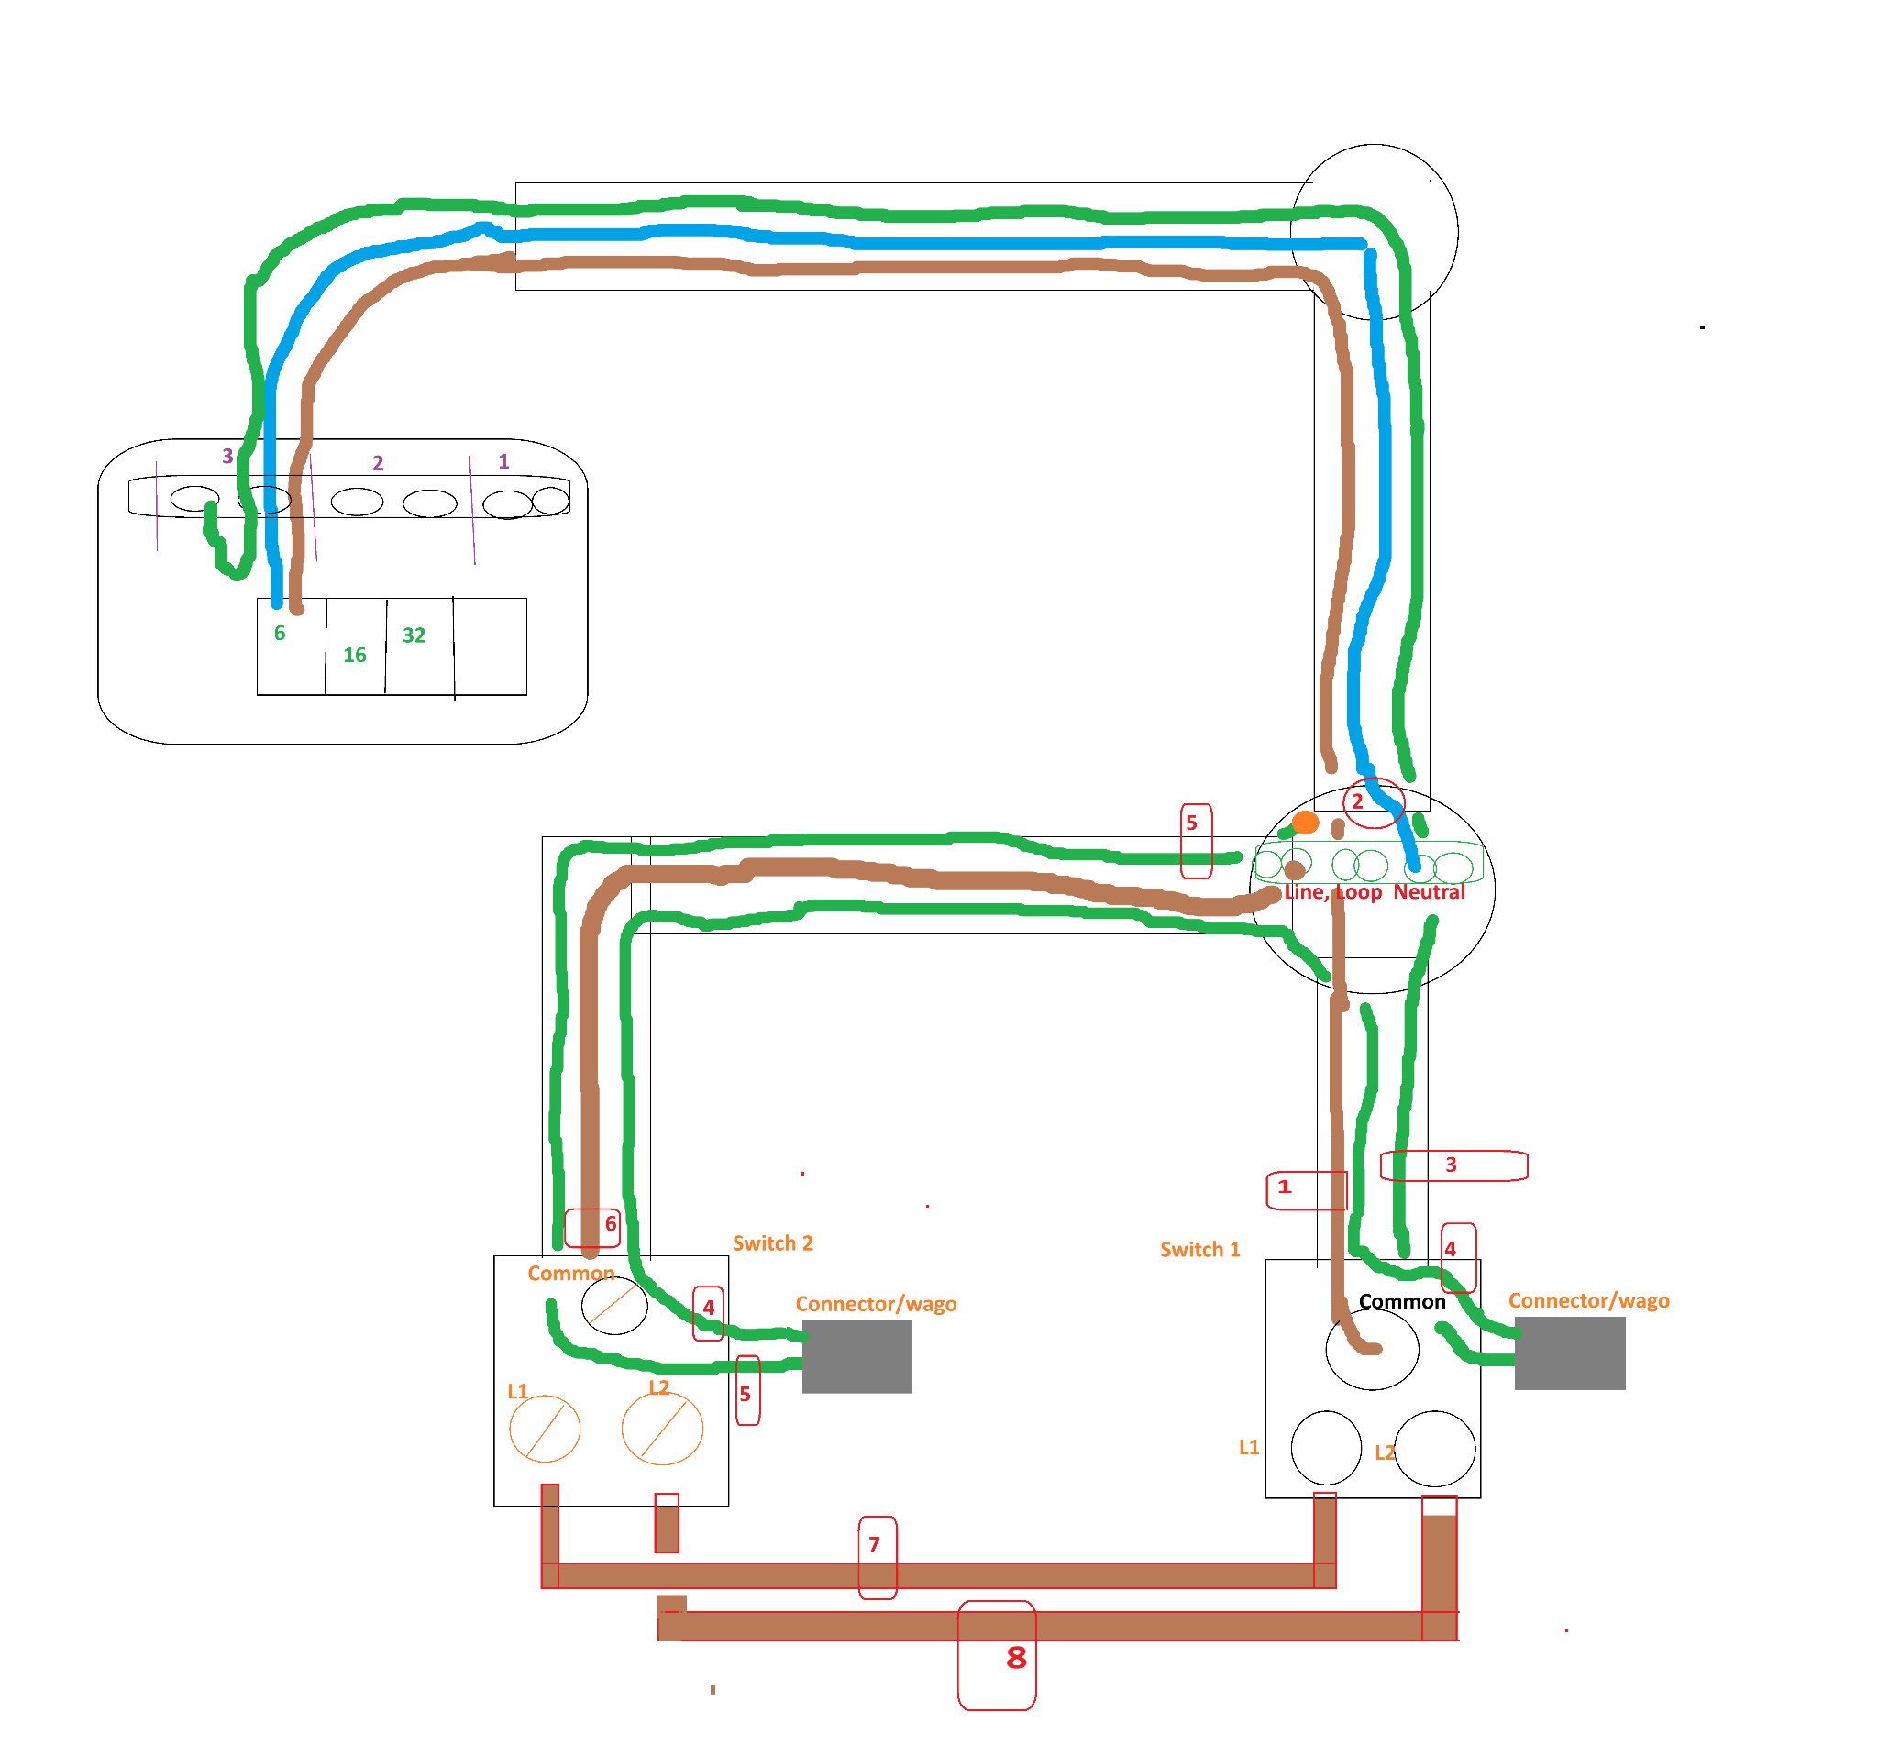

Step three - strappers

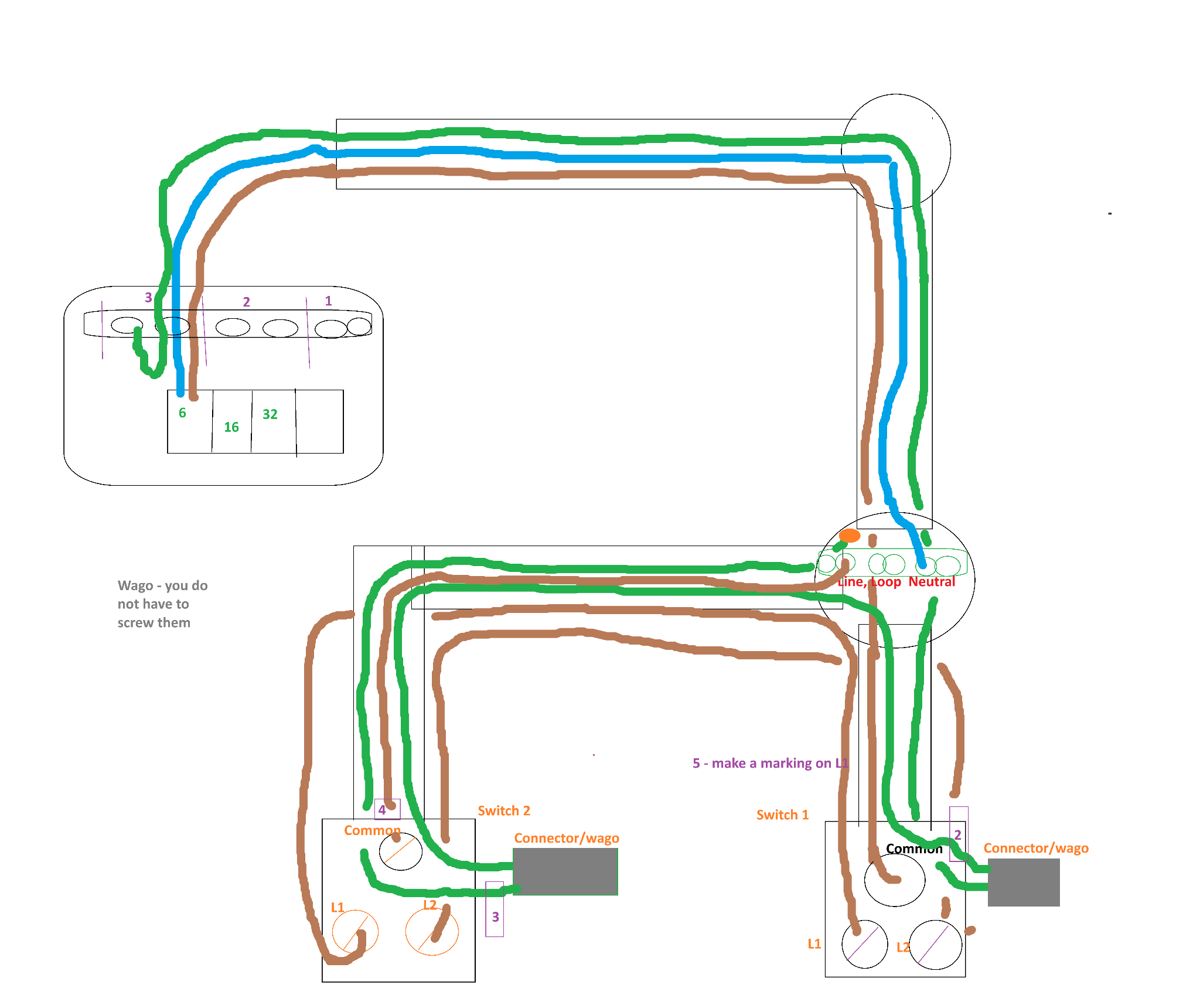

Steel conduit - Ring Circuit

Is on a 32 amp breaker.
The ring circuit as long as you have 2 blue 2 brown and 2 green at every point that means you will have the same at the fuse board both L and N both connected to the breaker and green to earth.

SWA Radial Circuit
The SWA radial circuit is on a 16 amp breaker.

The swa brown, black and grey in the fuse board black is earth. Grey is n. Don’t forget sleeving. You will be fine.

Brown => Live
Black => yellow/green sleeving => earth
Grey=> Blue sleeve => Neutral

